Sir Syed University of Engineering & Technology (SSUET)

Department of Software Engineering

Course Name: Artificial Intelligence (SE-314L)
Semester: 5th
Batch: 2023F
Section “F”

PROJECT REPORT

Project Title: Skin Disease Detection



Submitted To:
Dr. Engr. Farheen Qazi
Engr. Samrah Shafiq

Submitted By:
Ubaid Baig (GL) 2023F-BSE-036
Zainab Fatima 2023F-BSE-008
Usman Ghani 2023F-BSE-391
Abdul Hadi 2023F-BSE-269

TABLE OF CONTENTS
S. No. | TOPICS | PAGE No.
1 | PROBLEM DOMAIN
2 | PROPOSED TREATMENT
3 | PLAN OF WORK
4 | PROJECT SCHEDULING
5 | SOFTWARE AND HARDWARE SPECIFICATIONS
6 | BLOCK DIAGRAM
7 | SYSTEM FLOW DIAGRAM
8 | USER GUIDE

TEAM PROFILE

- Ubaid Baig (2023F-SE-036)
Trained the CNN model using TensorFlow, implemented callbacks.

- Zainab Fatima (2023F-SE-008)
Collected and cleaned dataset, balanced classes, performed image preprocessing, and split dataset into train, validation, and test sets.

- Usman Ghani (2023F-SE-391)
Developed Streamlit-based GUI, implemented image upload, prediction display, bar charts, and treatment recommendations

- Abdul Hadi (2023F-SE-269)
Report Documentation & GUI

1. PROBLEM DOMAIN
Skin diseases are one of the most common health problems affecting people of all ages. Early detection of skin diseases such as acne, eczema, psoriasis, rosacea, vitiligo, and warts is important for proper treatment and prevention of complications. However, in many cases, people do not have immediate access to dermatologists, which can delay diagnosis.
The problem addressed in this project is the lack of an automated and easily accessible system that can assist users in identifying skin diseases based on images. Manual diagnosis is time-consuming, subjective, and requires expert knowledge. This creates a need for an intelligent system that can analyze skin images and provide accurate predictions.
The objective of this project is to develop an AI-based skin disease detection system using a Convolutional Neural Network (CNN) that can classify different skin diseases from images and provide a user-friendly interface for prediction.

2. PROPOSED TREATMENT
To solve the stated problem, an Artificial Intelligence based solution using Deep Learning is proposed. The system uses a Convolutional Neural Network (CNN) trained on a dataset of skin disease images. The CNN model automatically learns important visual features such as texture, color variations, and patterns from images.
The proposed system allows users to upload a skin image through a graphical user interface. The uploaded image is preprocessed and passed to the trained CNN model, which predicts the most probable skin disease along with its percentage. The system also provides basic treatment recommendations for the detected disease.
This approach reduces dependency on manual diagnosis and provides quick assistance, especially for preliminary screening.

3. PLAN OF WORK
The project was carried out in a structured manner and divided into multiple phases. Initially, research was conducted on skin diseases and CNN-based image classification techniques. After that, the dataset was collected and cleaned.
The project tasks were divided among team members, including dataset preparation, model development, training and evaluation, and GUI development. Regular discussions were conducted to monitor progress. The CNN model was trained and evaluated multiple times to improve performance. Finally, a Streamlit-based user interface was developed to integrate the trained model.

4. PROJECT SCHEDULING
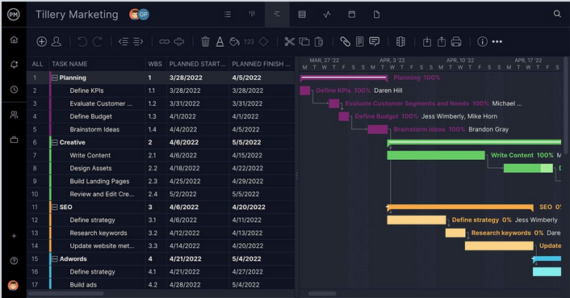
Figure 4.1: Sample Gantt Chart
OR
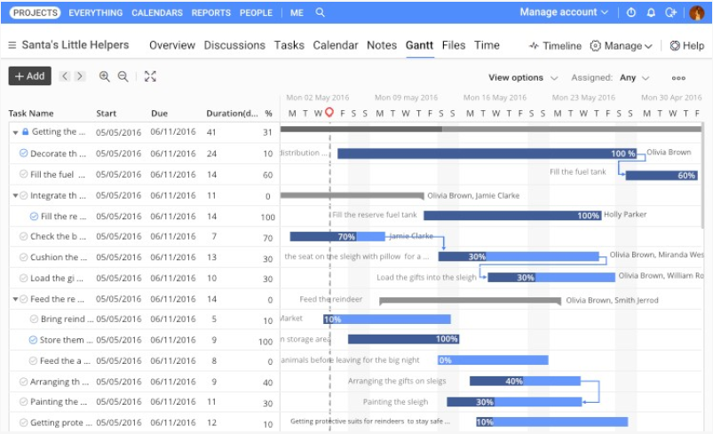
Figure 4.2: Sample Gantt Chart

5. SOFTWARE AND HARDWARE SPECIFICATIONS

Hardware Requirements
- Processor: Minimum 1 GHz (Recommended 2 GHz or more)
- RAM: Minimum 4 GB
- Storage: Minimum 64 GB
- Internet Connection
- Camera (optional for future extensions)
Software Requirements
- Operating System: Windows 10 or above
- Programming Language: Python
- Frameworks & Libraries:
  - TensorFlow / Keras
  - OpenCV
  - NumPy
  - Matplotlib
  - Streamlit
- Development Environment:
  - Jupyter Notebook
  - VS Code / Thonny

8. USER GUIDE
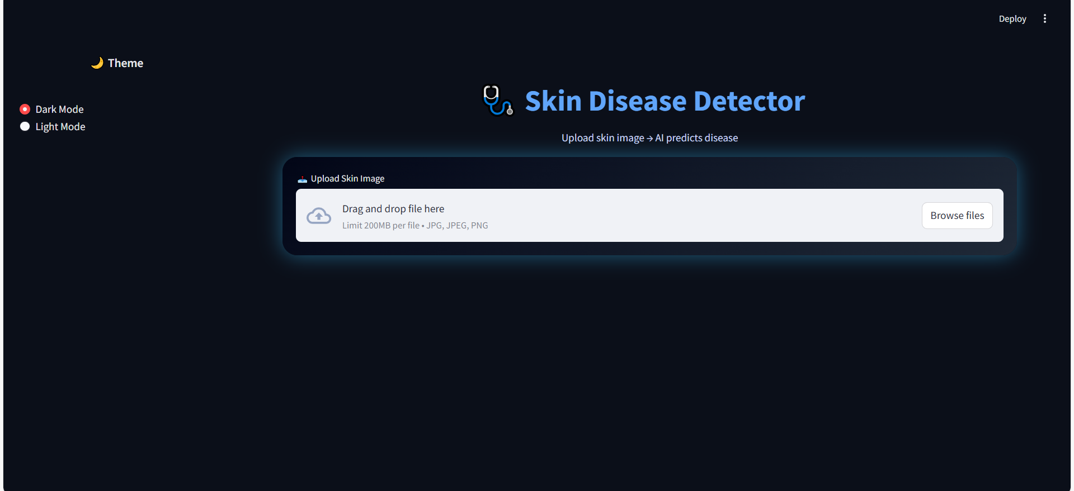

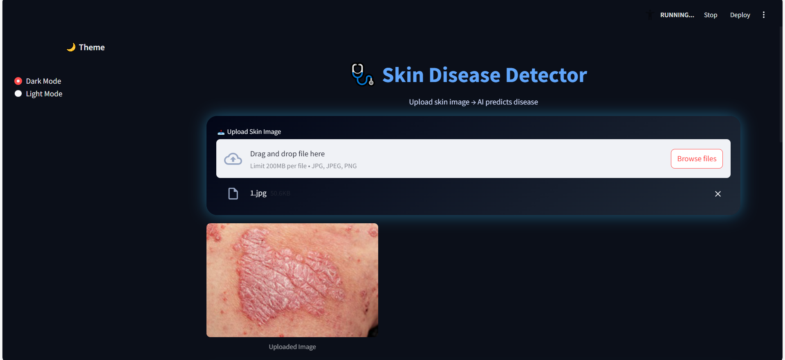

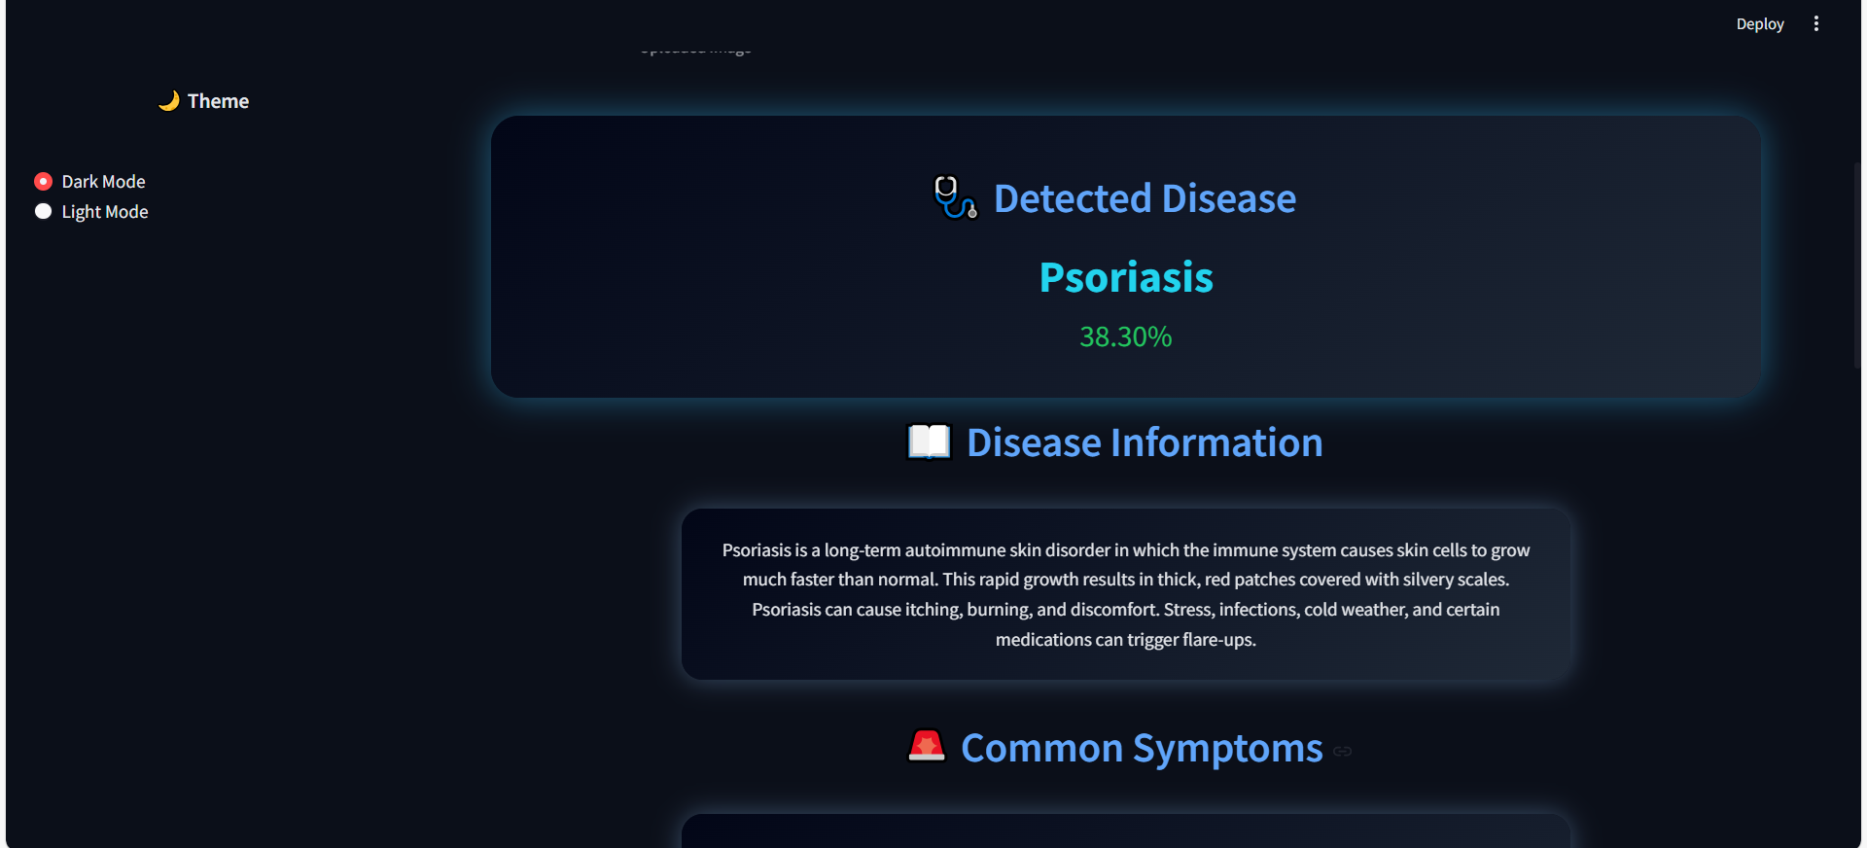
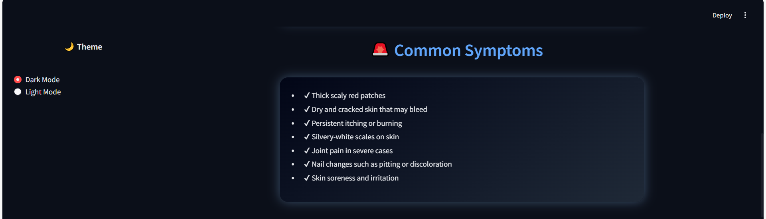
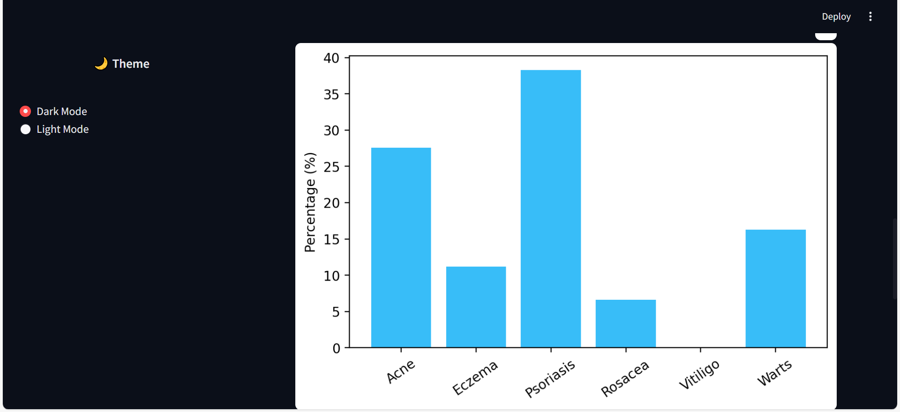
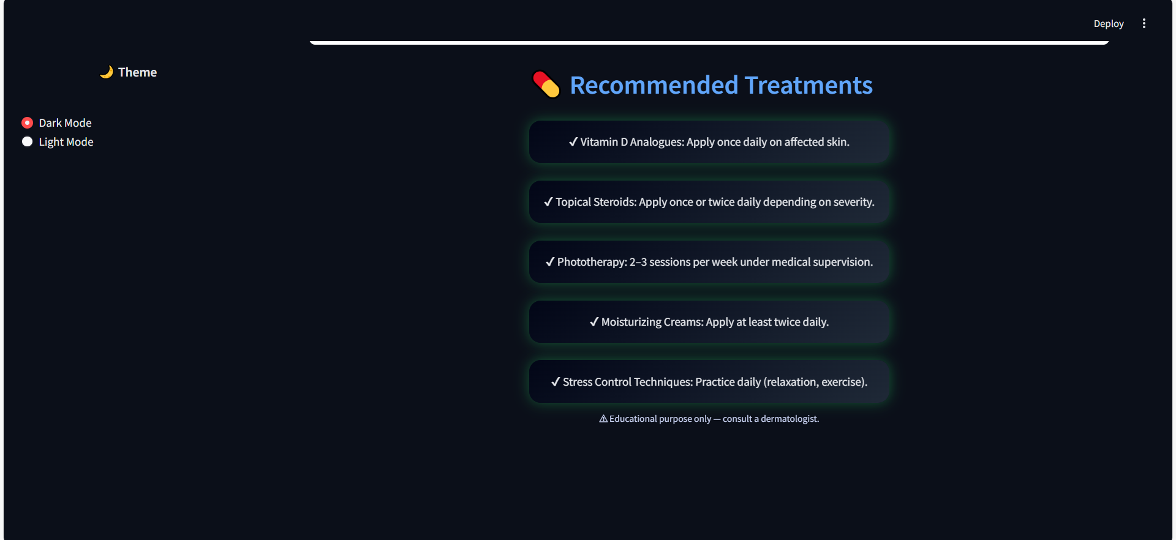

REFERENCES
Include all references here.

INSTRUCTIONS
- You have to implement AI based algorithms or libraries in your project.
- Try to implement the project on your own, must not be cheat or copy from anywhere and must believe that you will achieve the target!
- The font size should be 14 for heading and 12 for the rest of text, font style should be Times New Roman. The font color should be black only.
- The header must contain the heading “Artificial Intelligence Project Report” in the middle and the footer must contain the heading “SIR SYED UNIVERSITY OF ENGINEERING AND TECHNOLOGY” on left side and page numbers on the right side through out in the report. The page number should start from “Problem Domain”.
- There can be only single line spacing between the lines.

